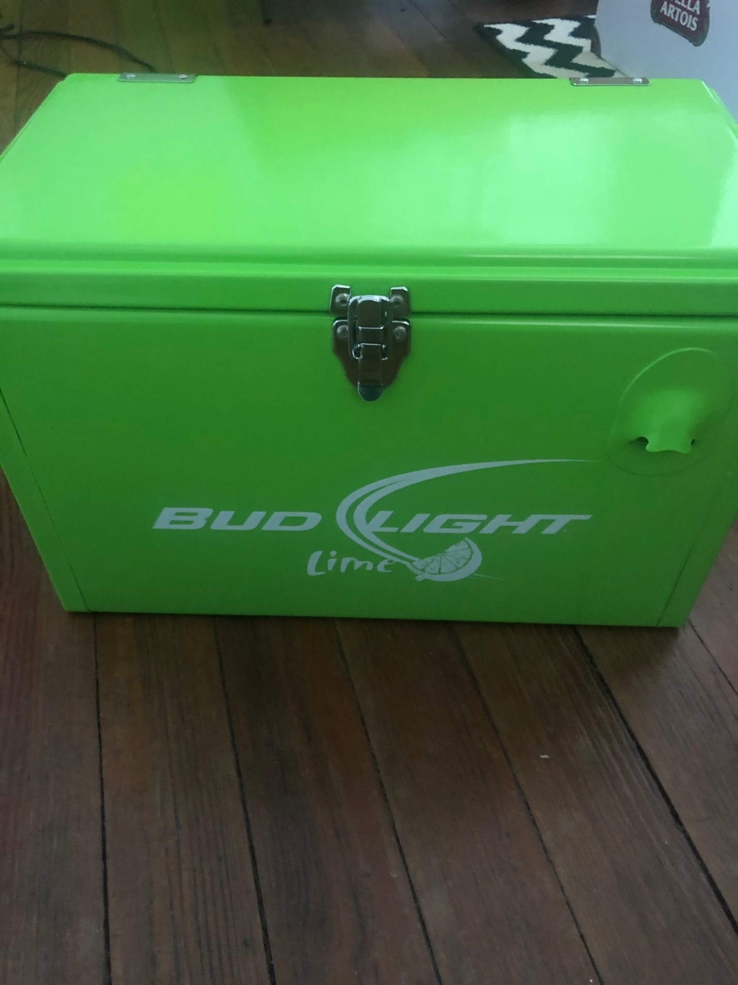

Bud Light Cooler

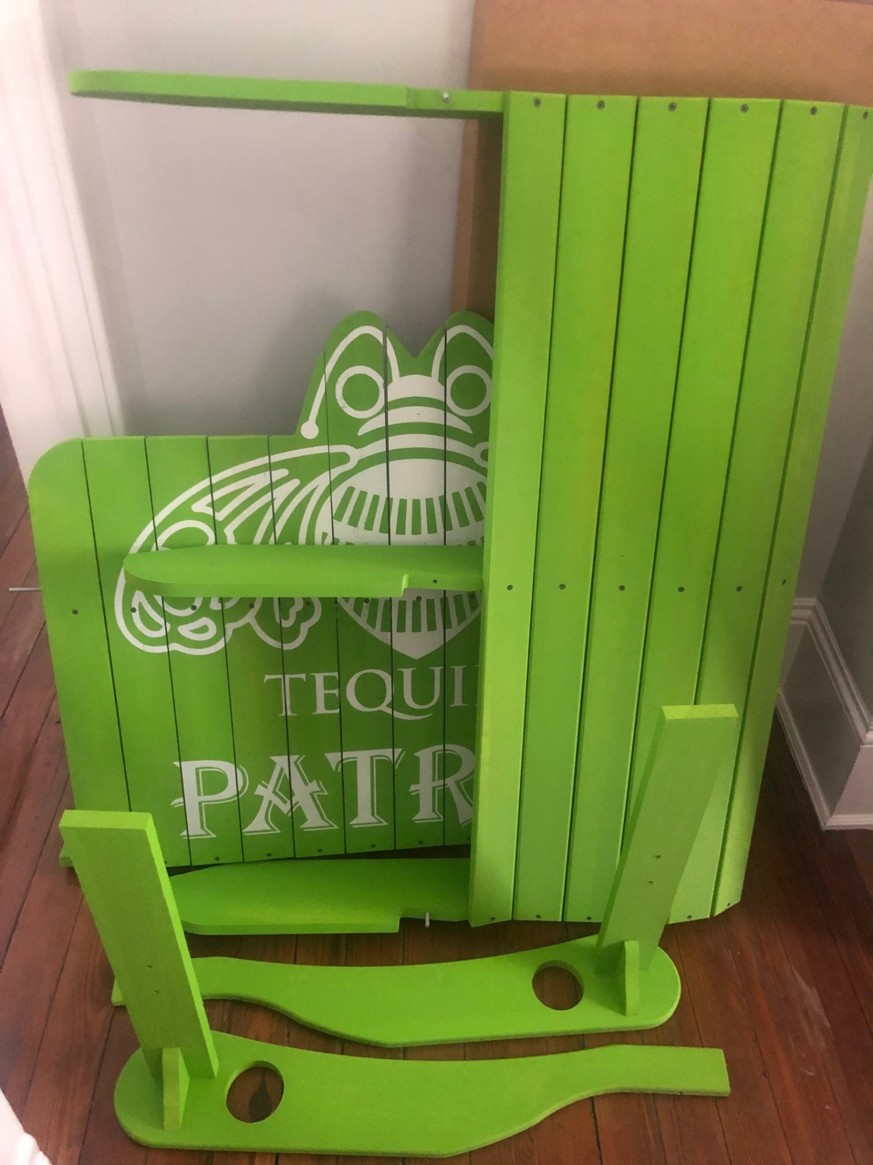

Double sized Adirondack chair – will be assembled and delivered if needed to the buyer !

Ter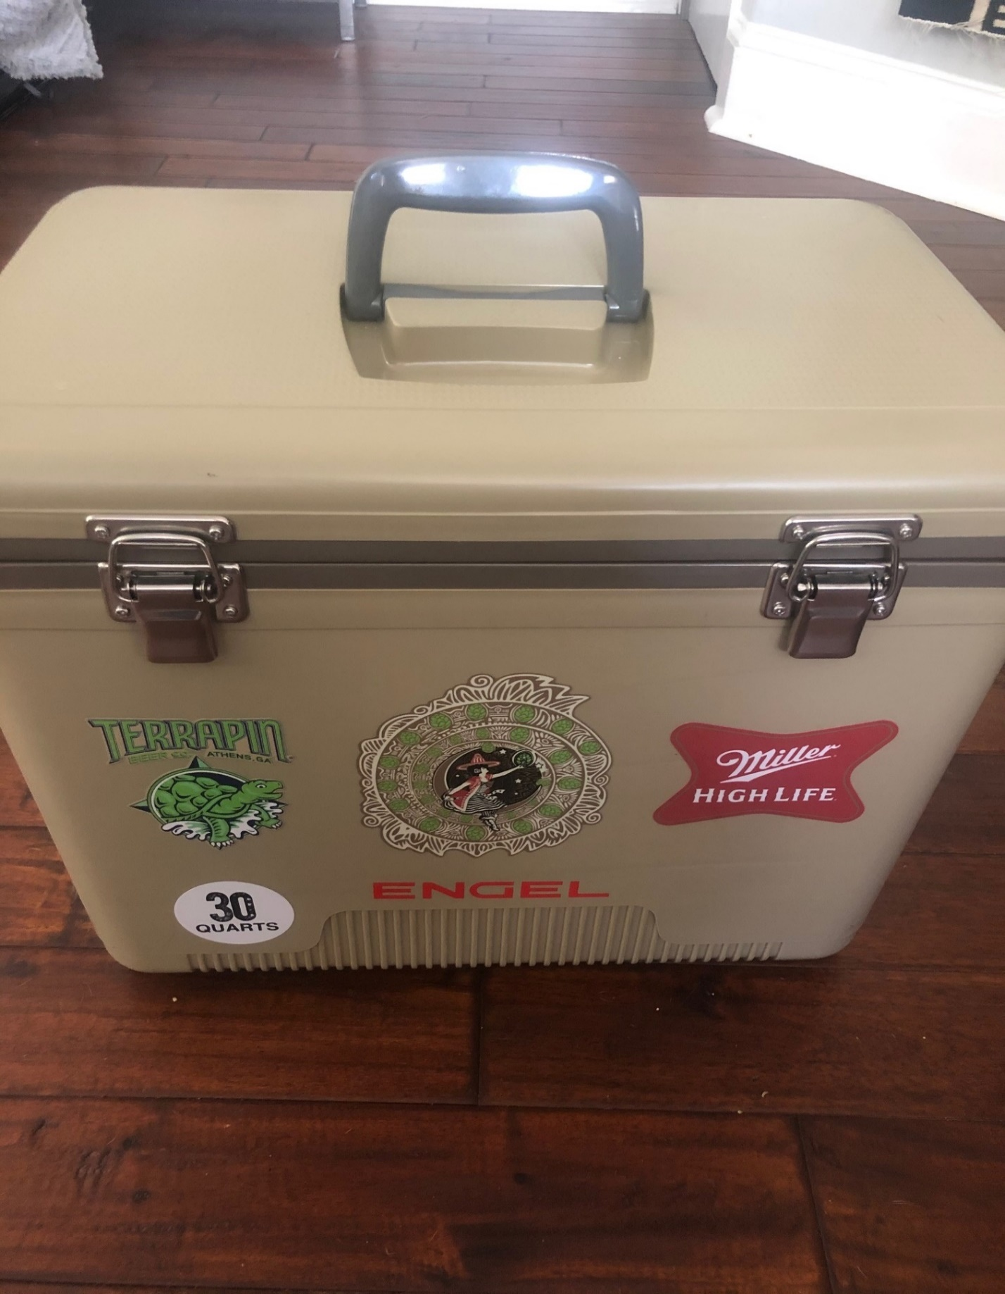

Terraping 30 Quart Cooler

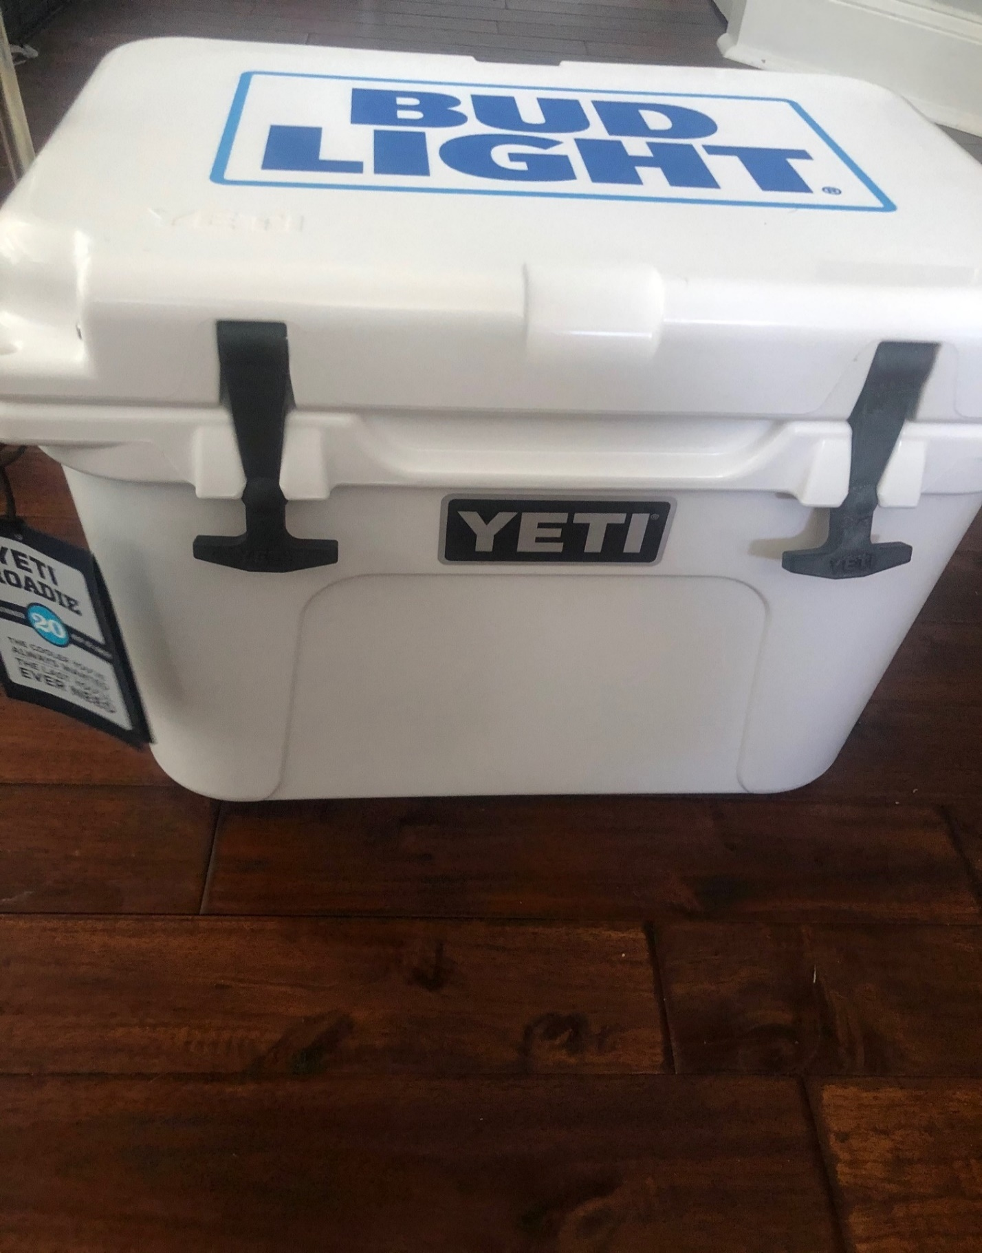

Yeti Roadie!!!

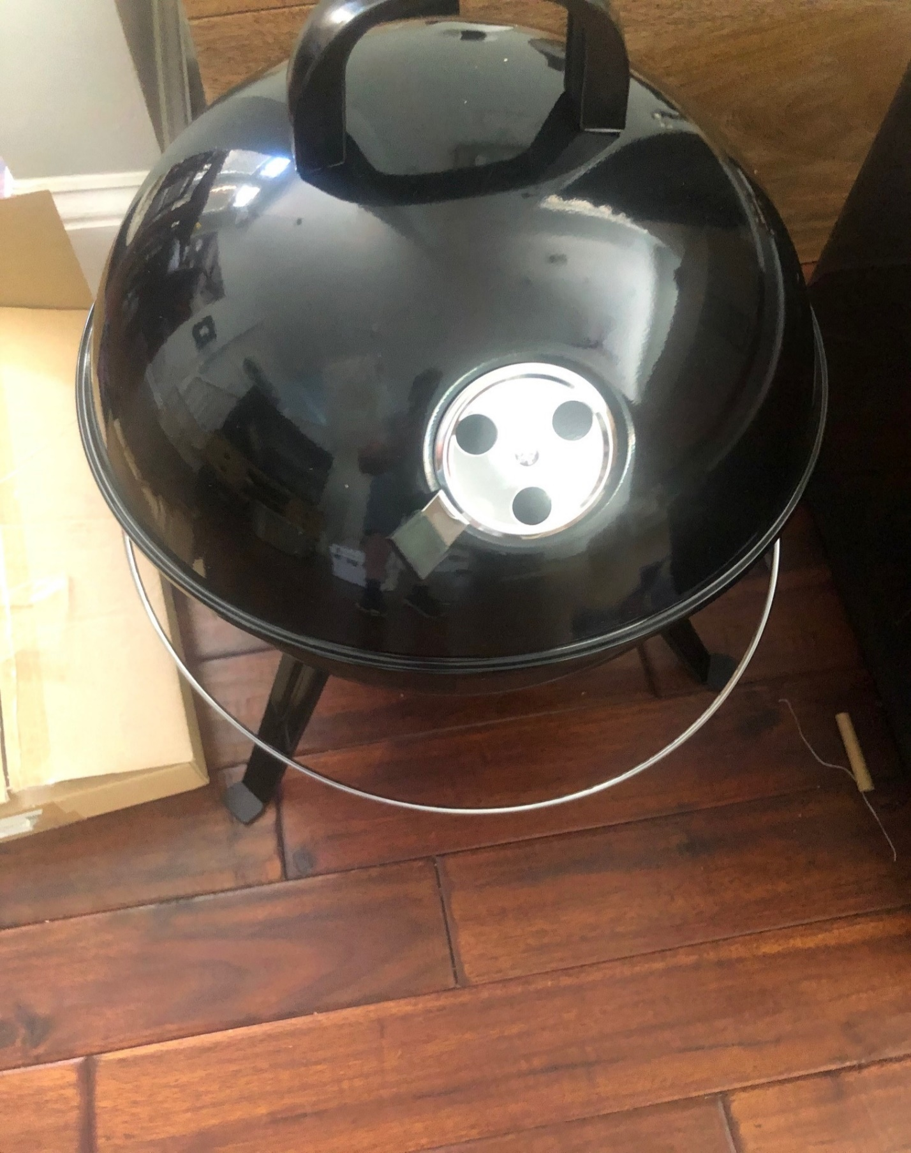

Guinness Charcoal tabletop grill

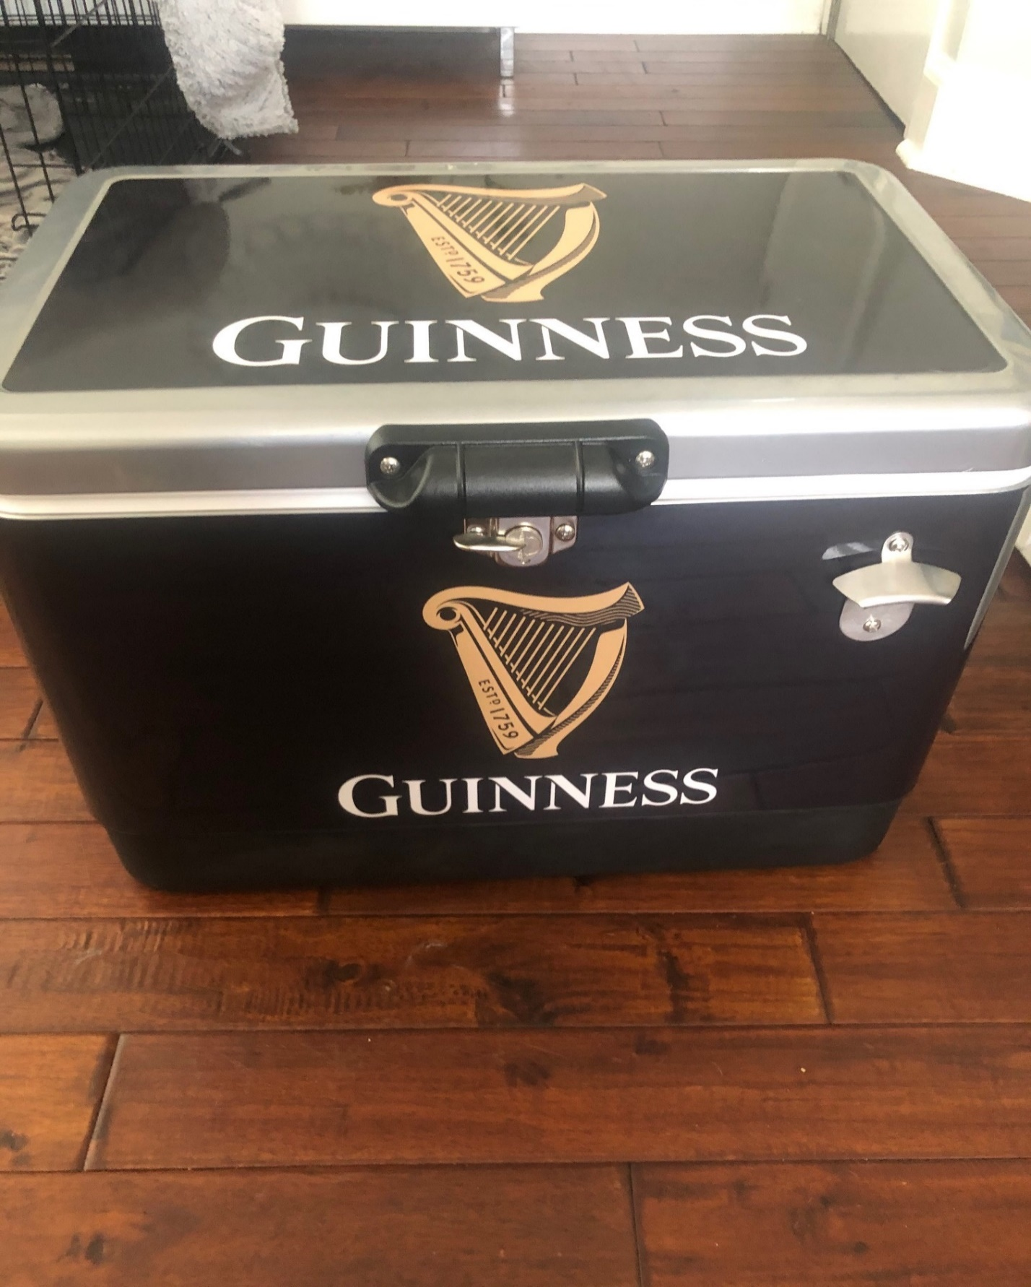

Really nice Guinness Cooler

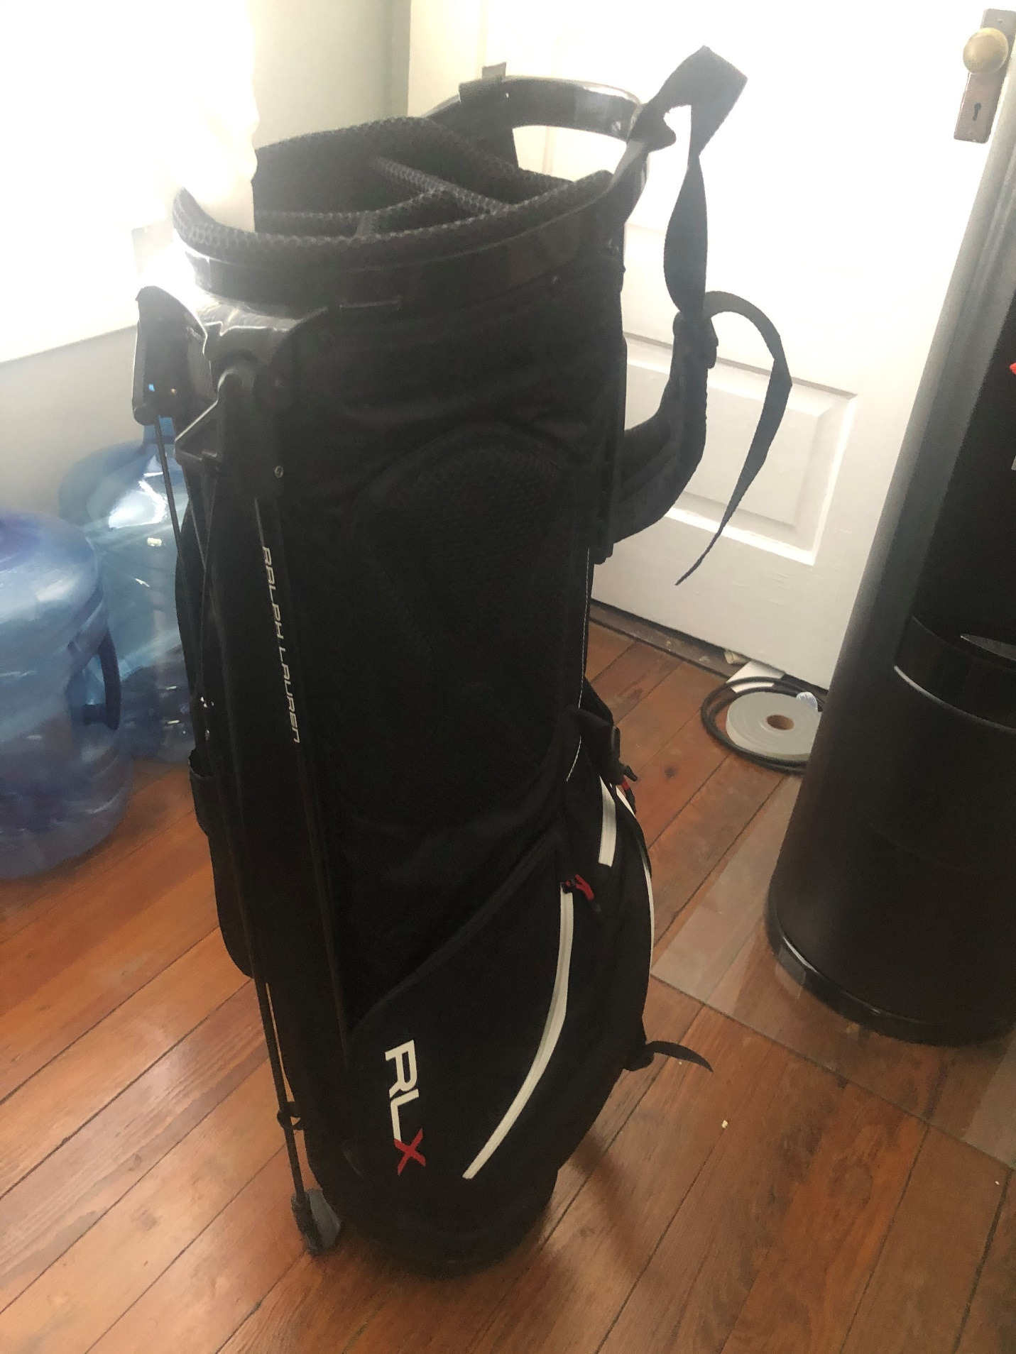

Ralph Laurent Golf Bag with a putter!

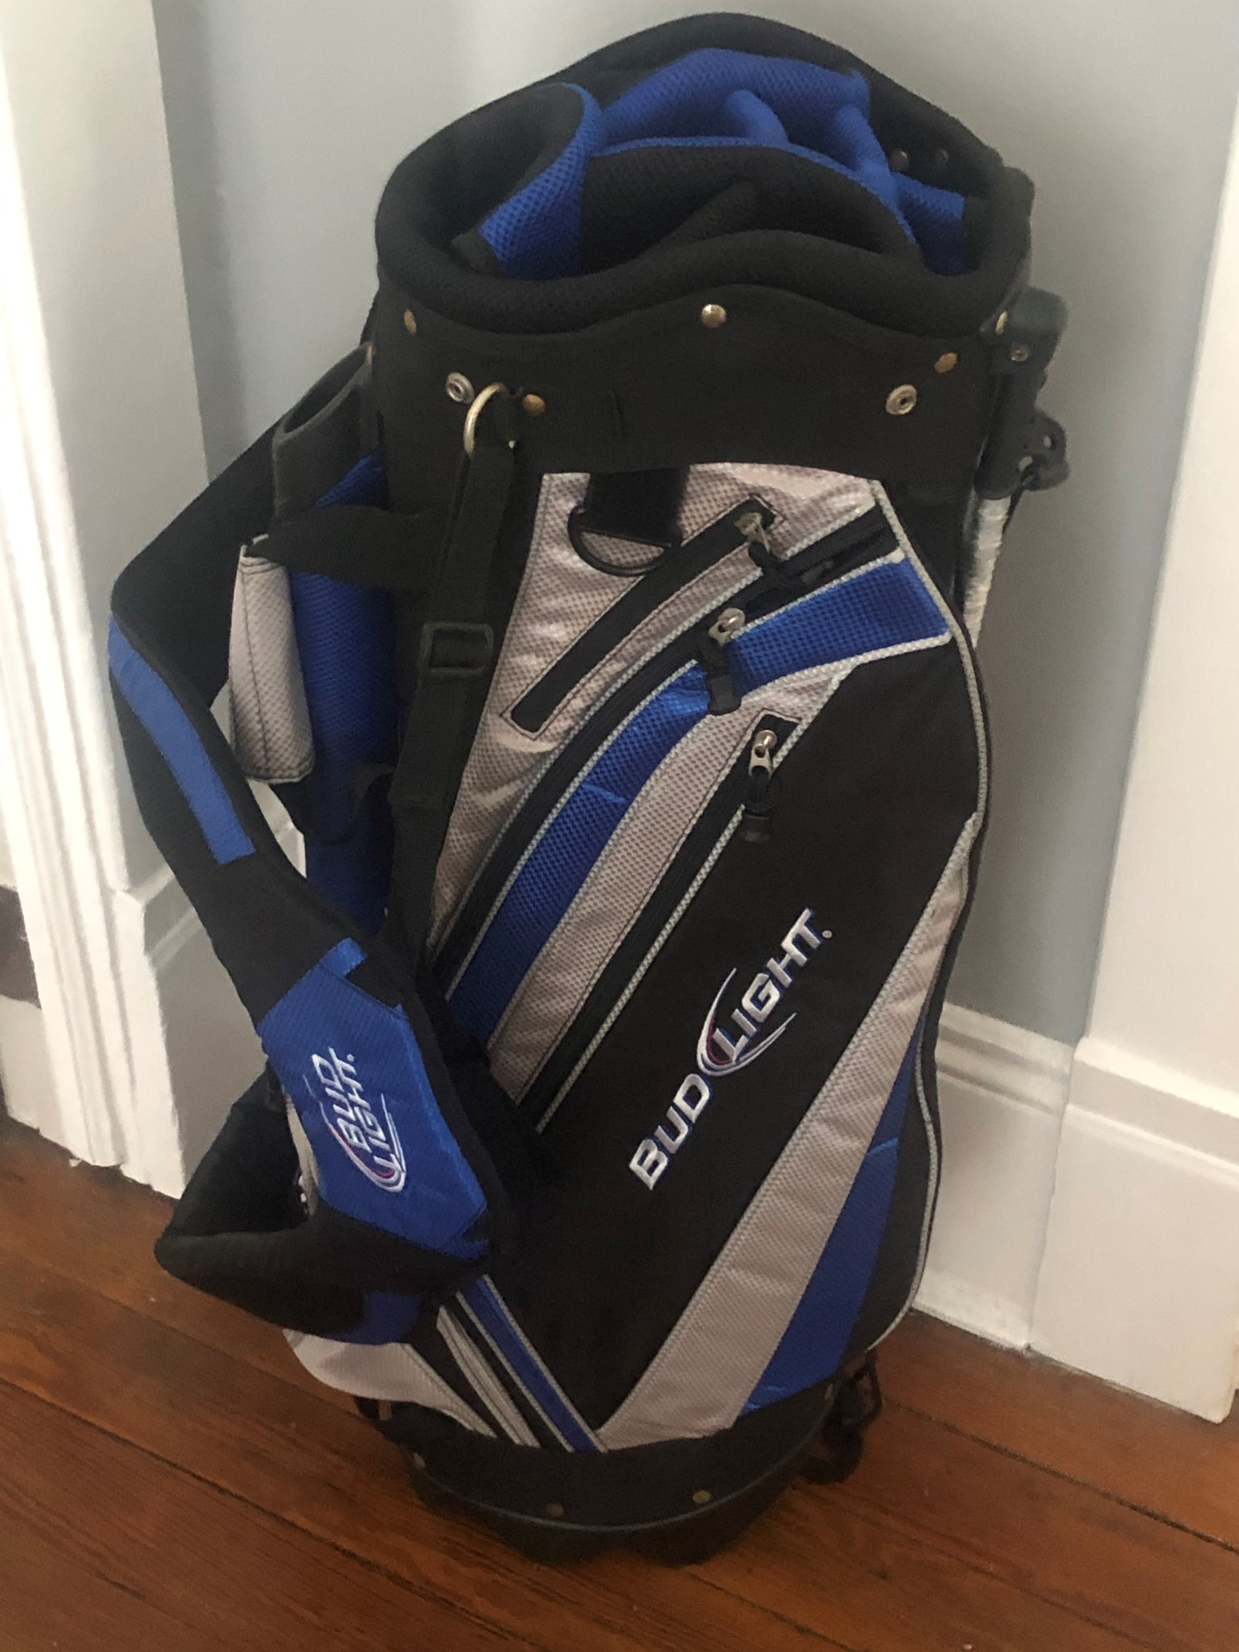

Ogio golf bag

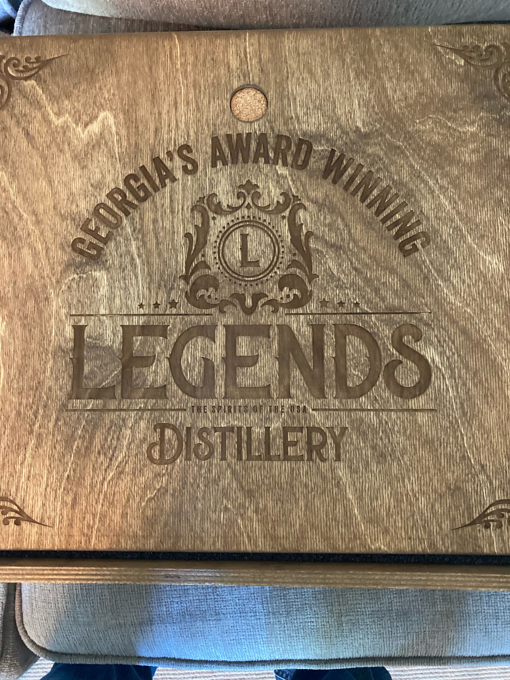

2 Legends gift boxes with glasses and top grade whiskey